
HWCH
WELDER – GENERATOR with Jumpstarter and Battery Charger for 12 – 24-36 Volt
HWCH – 200-4
200 AMP and 4000 Watt AC 250 AMP JS and BC @12- 24- 36 V
FLOW 12 GPM @ 2000 PSI

HWCH – 250-5.5
250 AMP and 5500 Watt AC 250 AMP JS and BC @12- 24- 36 V
FLOW 18 GPM @ 2000 PSI

HWCH – 300-6
300 AMP and 6000 Watt AC 350 AMP JS and BC @12- 24- 36 V
FLOW 18 GPM @ 2000 PSI

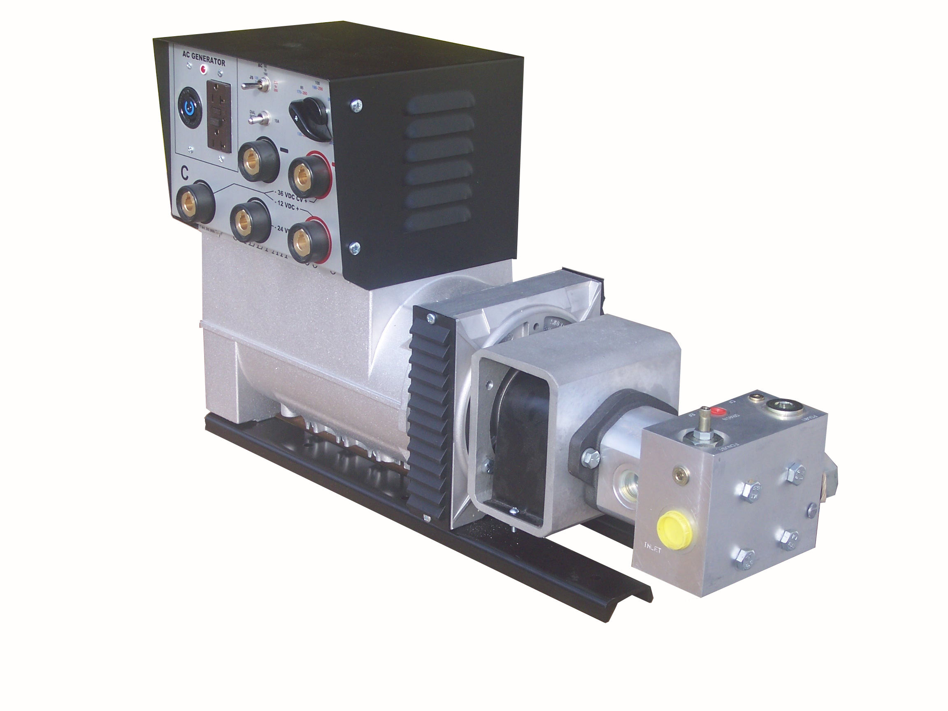

HWCH – 300-10
300 AMP and 10 000 Watt AC
350 AMP JS and BC @12- 24- 36 V
FLOW 18 GPM @ 2200 PSI

HWCH – 400-10
400 AMP and 10 000 Watt AC
450 AMP JS and BC @12- 24- 36 V
FLOW 18 GPM @ 2200 PSI

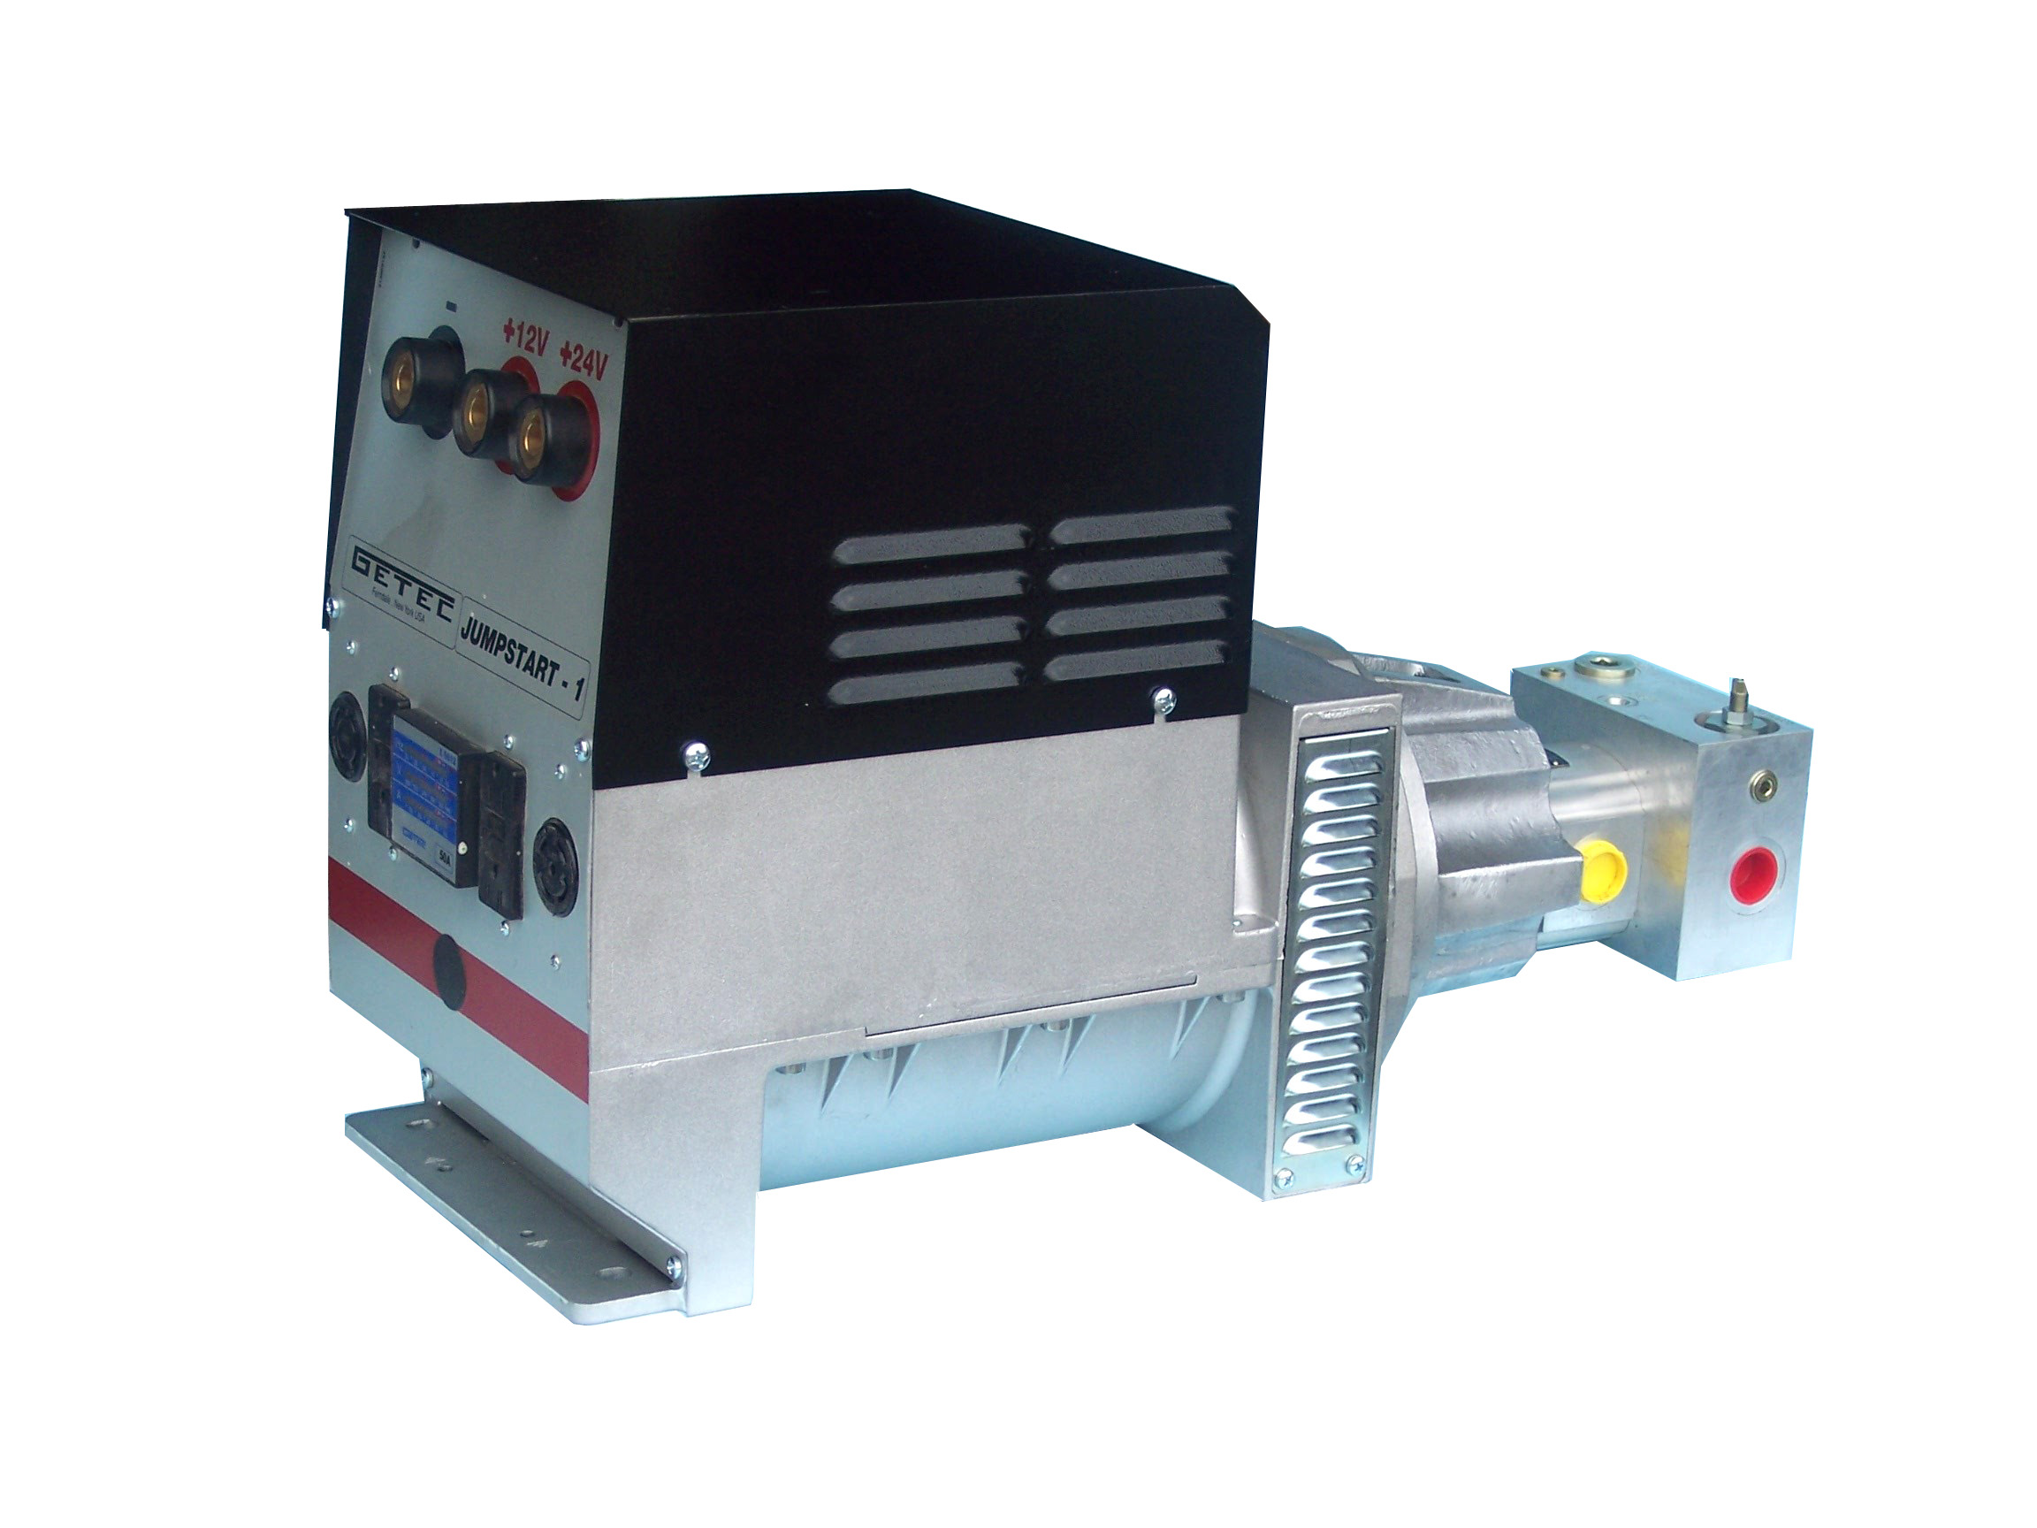

Maintenance Free
Lifetime lubricated Bearings
Patented Precise Motor to Generator Alignment
GETEC Inc.
624 Harris Road – Ferndale, N.Y. 12734 Tel. 1 (845) 292 0800
Email: hans@getec.com Website: www.geteck.com

