JUMPSTART
HJS 1000-1224

HYDRAULICALLY-DRIVEN

VEHICLE JUMP STARTER

BY 

1000 Amp
@
12 Volt

1000 AMP
@
24VDC

WATT
120/240 V

12 Volt
24 Volt
DC

120 / 240
AC

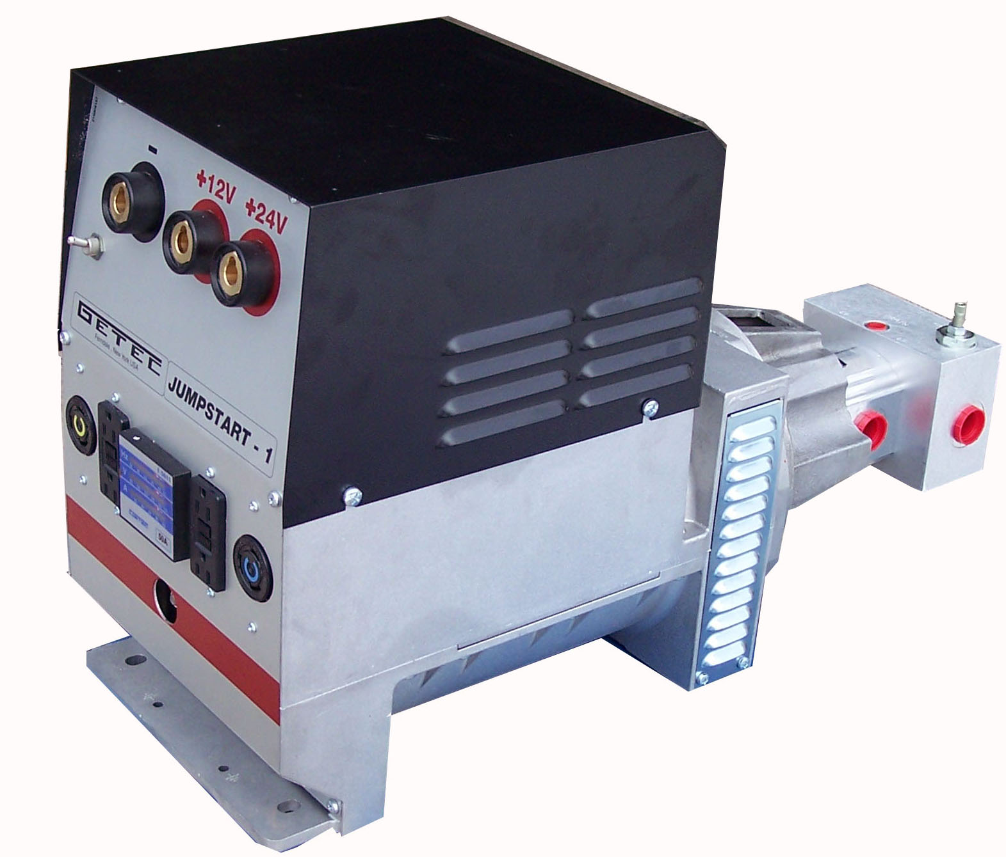

QUALITY FEATURES
No Load Brushes |  | Jumpstarter and Generator Combo
Maintenance Free Design |  | Over Load Protected

SPECIFICATIONS
AC Volts | 120V or 120/240 V |  | Volts DC | 12 and 24 Volt
AC Watts | 6000W |  | Amps DC | 1000 @ 12 and 24 Volt
Speed | 3600 RPM |  | Hydr.Flow | 24 GPM min
Weight | 136 Lbs |  | Hydr.Pressure | 2400 PSI
Dimensions | 12W x 16H x 32L |  | Controllable Flow | 24 to 45 GPM
FERNDALE, NY 12734
(845)-292-0800
http://www.geteck.com

