HYDRA-WELD 300-4-6

HYDRAULICALLY-DRIVEN
DC WELDER & AC GENERATOR

BY 

300
Amp
DC
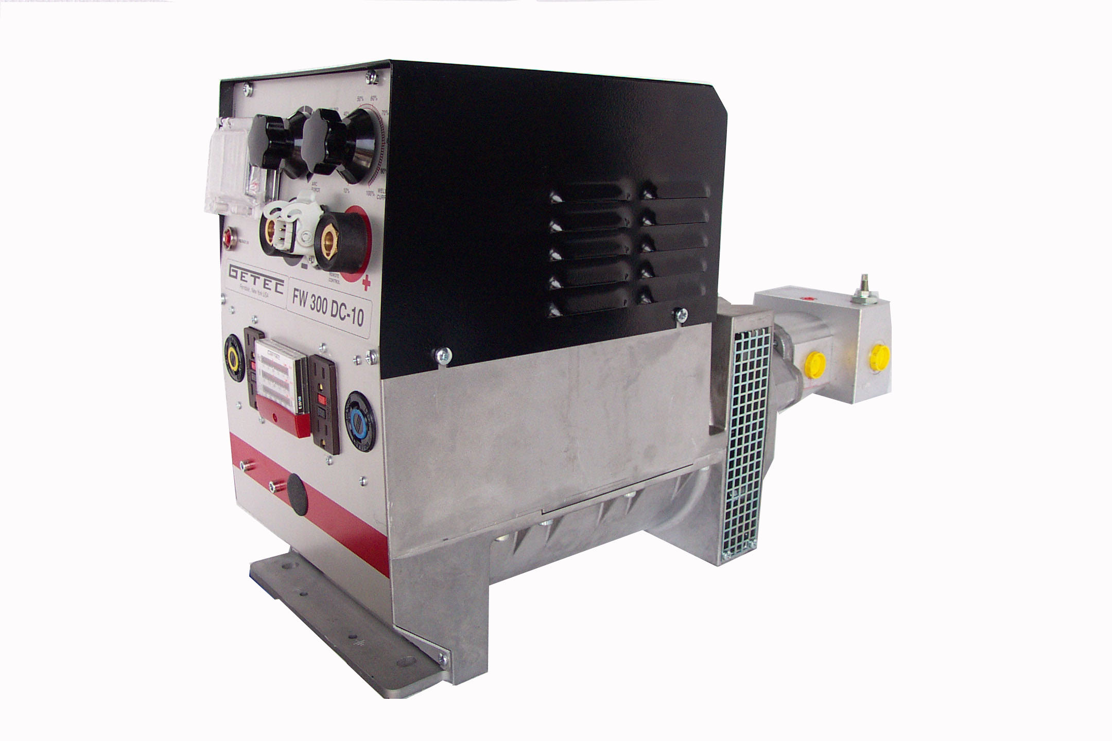

120 /
240 V
60 Hz
6000
Watts

QUALITY FEATURES
300 DC Amps |  |  | Generator Output : | 6 000 Watt
Continuous Fine Control |  |  |  | 120 Volt or 120/240 Volt
70% Duty Cycle |  |  | Frequency : | 60 Hz
Locking Weld Receptacles |  |  | Size : | 29”L * 11”W * 17”H
Volt – Freq.Meter |  |  | Weight : | 158 lbs.
Strike Voltage : | 82 VDC |  | Flow : | 20 G.P.M.
Weld Voltage : | 22 – 28 VDC |  | Pressure : | 2200 PSI Max
FERNDALE, NY 12734
(845)-292-0800
http://www.geteck.com

