HYDRO-MAX HMP-13T

HYDRAULICALLY-DRIVEN

3 Phase AC GENERATOR

BY 

120 /
208 V
60 Hz

13 kva
3 Phase
\
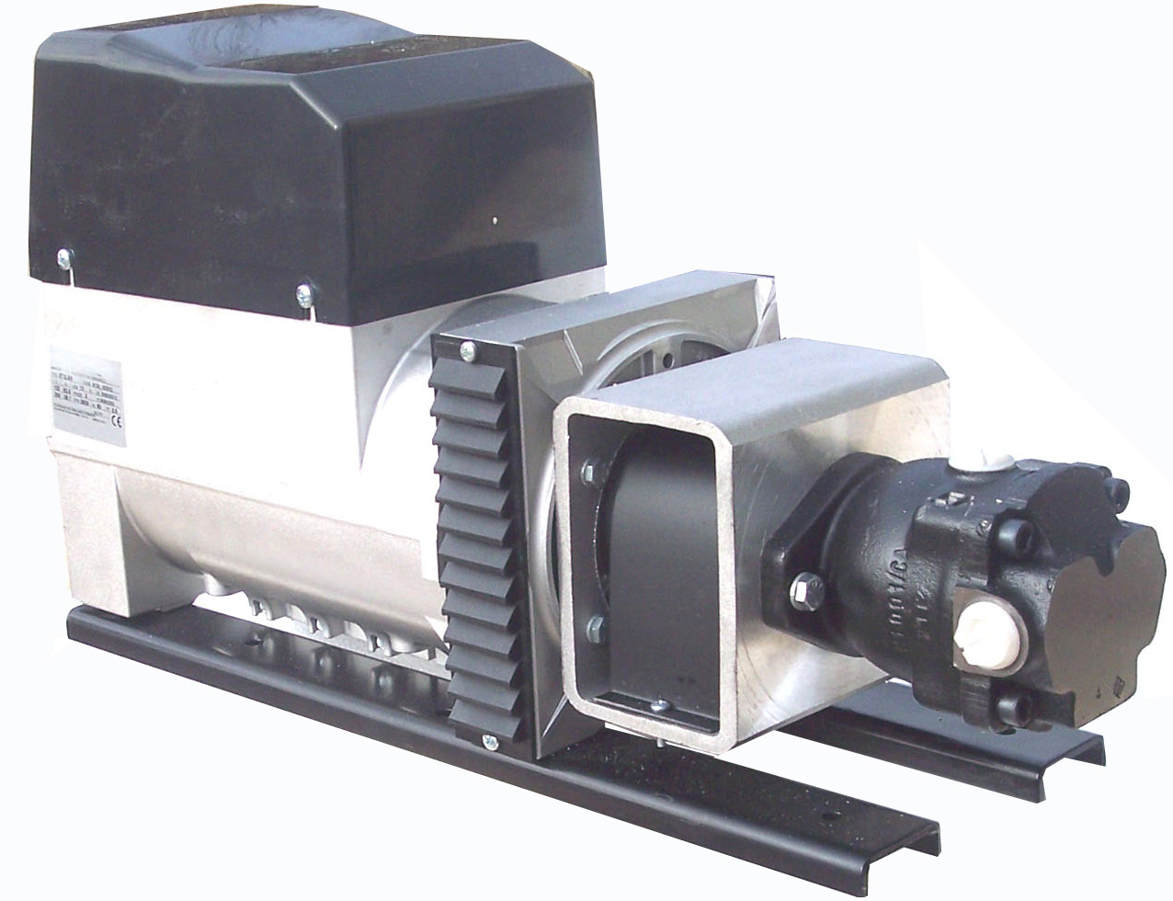

QUALITY FEATURES
Transformer regulated |  | Optional Pressure Compensating Flow Regulator
Maintenance Free Design |  | AXIAL Piston Motor 17 cc

SPECIFICATIONS
Flow = | 17 GPM |  | Volts = | 120 and 208 Volt
Pressure = | 2000 PSI |  | Amps = | 36 A @208 Volt
Speed = | 3600 RPM |  | Watts = | 13 kva Continuous
Weight = | 143 Lbs |  | Power Factor = | .8
Dimensions = | 8” W * 14” H * 27” L |  | Temperature Rating = | 105 C
FERNDALE, NY 12734
(845)-292-0800
http://www.getec.com
geteck.com

